Design 1 annotations
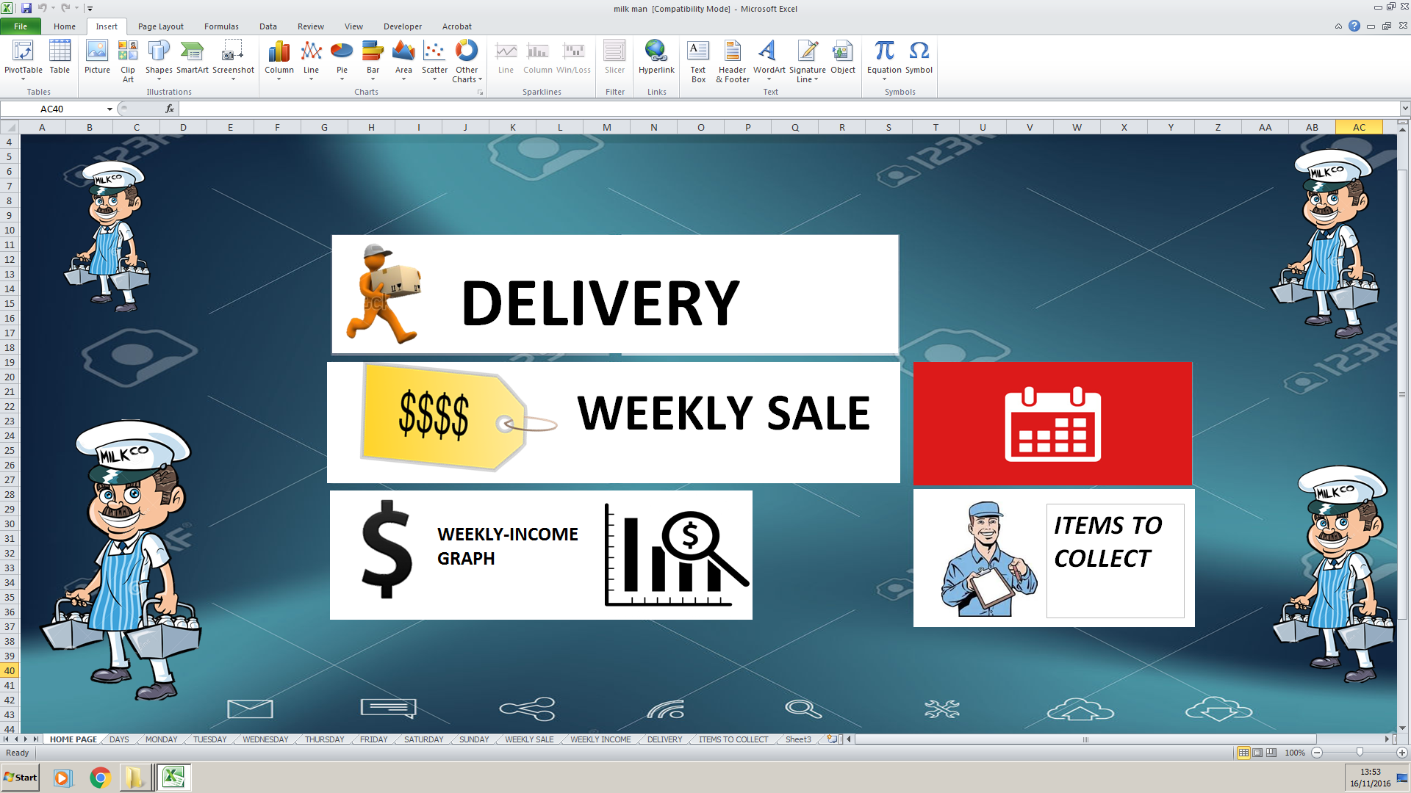
This menu page if you click any of the boxes you will access a spreadsheet with information reliable to the boxes.
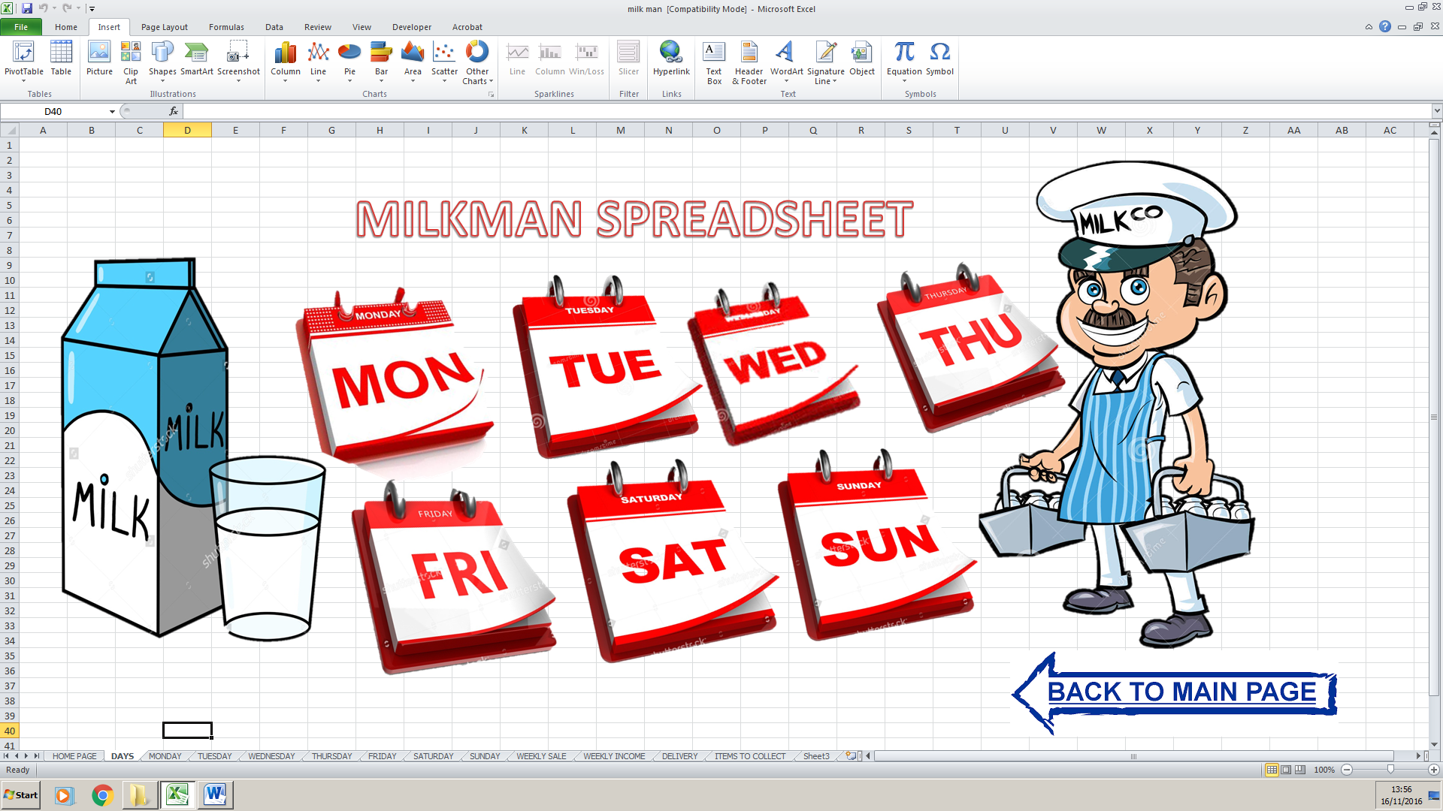
if the milkman click any of the mini calendars the milkman will access a spreadsheet of that day ,and by the milkman clicking the back to main page he will go back to the main menu page.
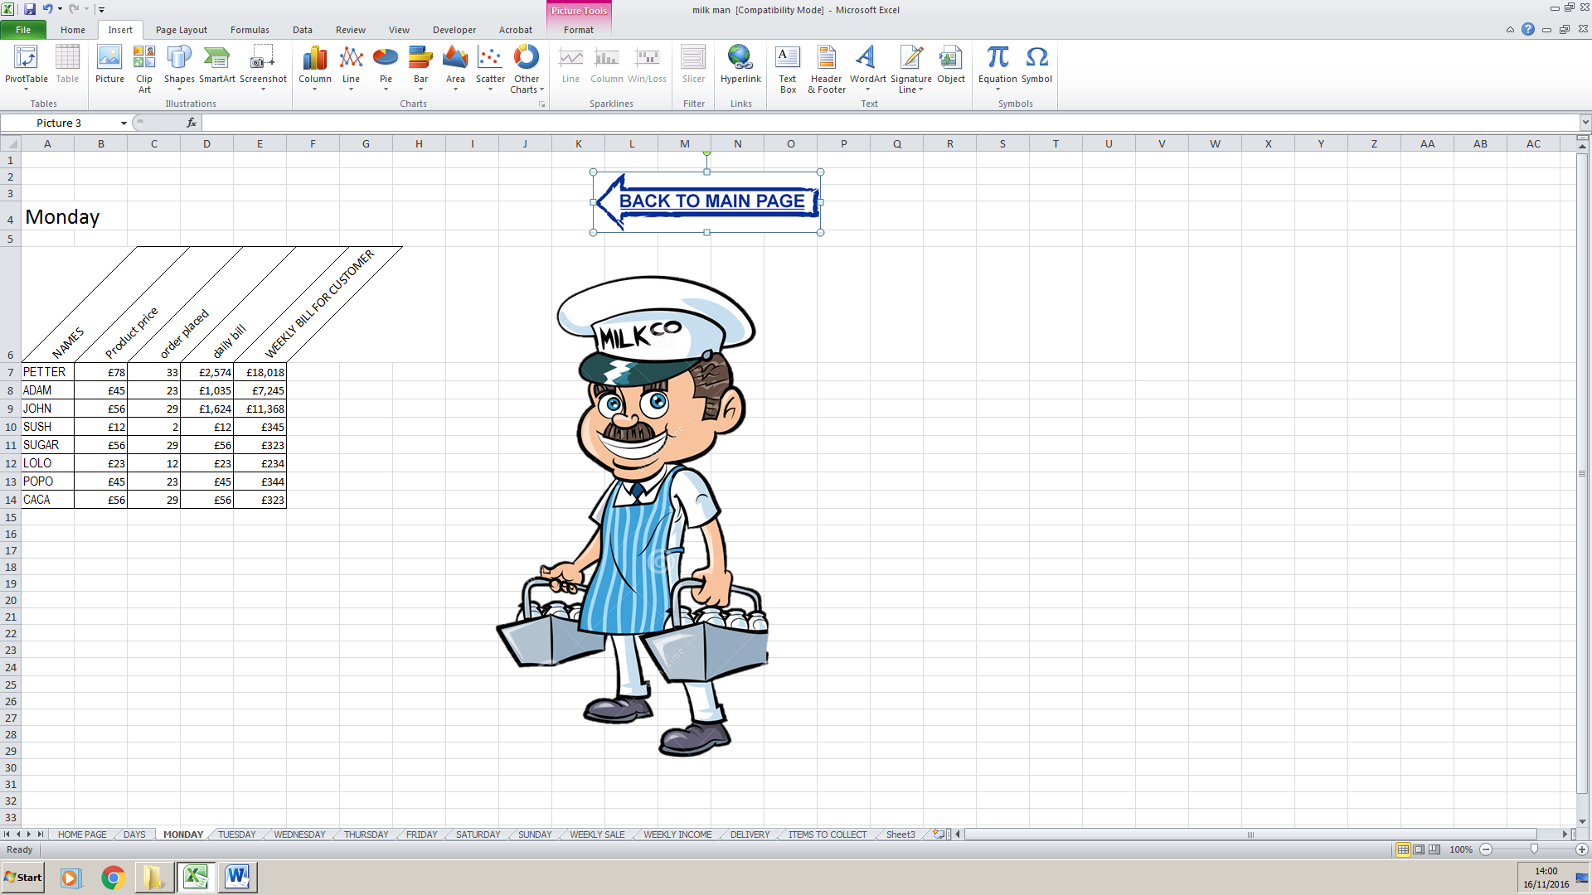
This is the spreadsheet that the milkman will access after he click the Monday mini calendar
Before
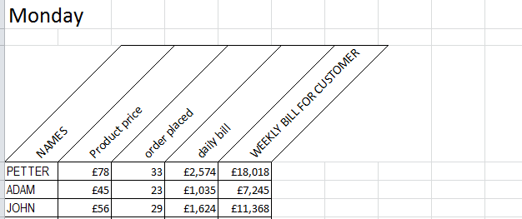
After
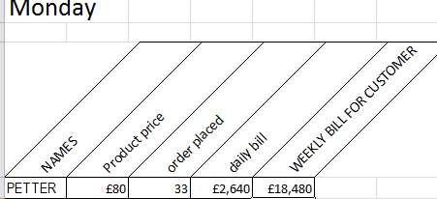
This show that the spreadsheet work because if you change the product price the daily bill and weekly bill for the customer will change.
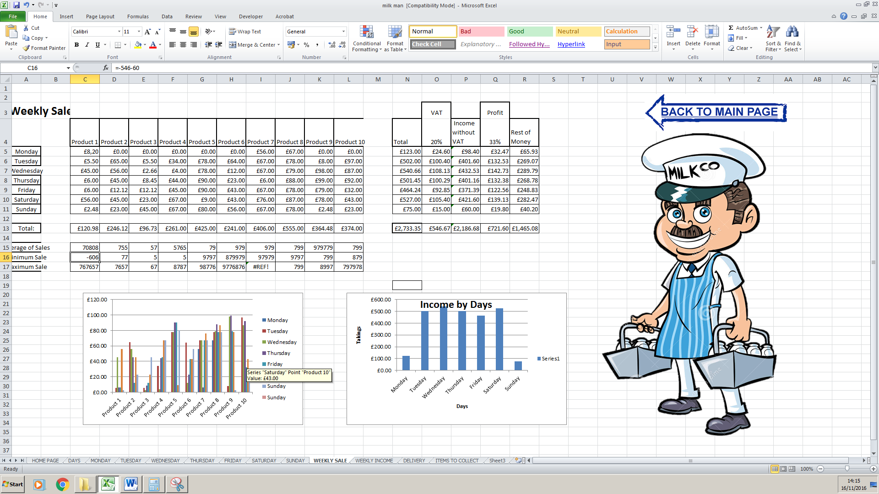this is the spreadsheet for the weekly sale for the milk man , in this spreadsheet the milkman can see is profit and is sales.
Before
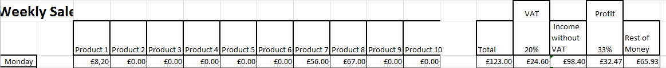
After
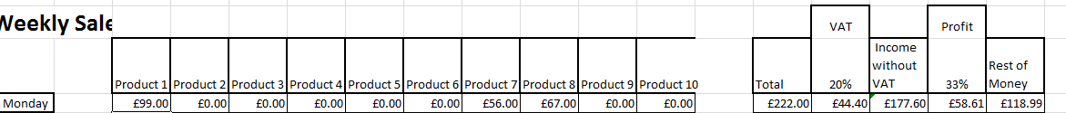
If the milkman change the Monday product 1 also the total,vat ,income without vat,profit and rest of money change and this screenshoot prove he work.
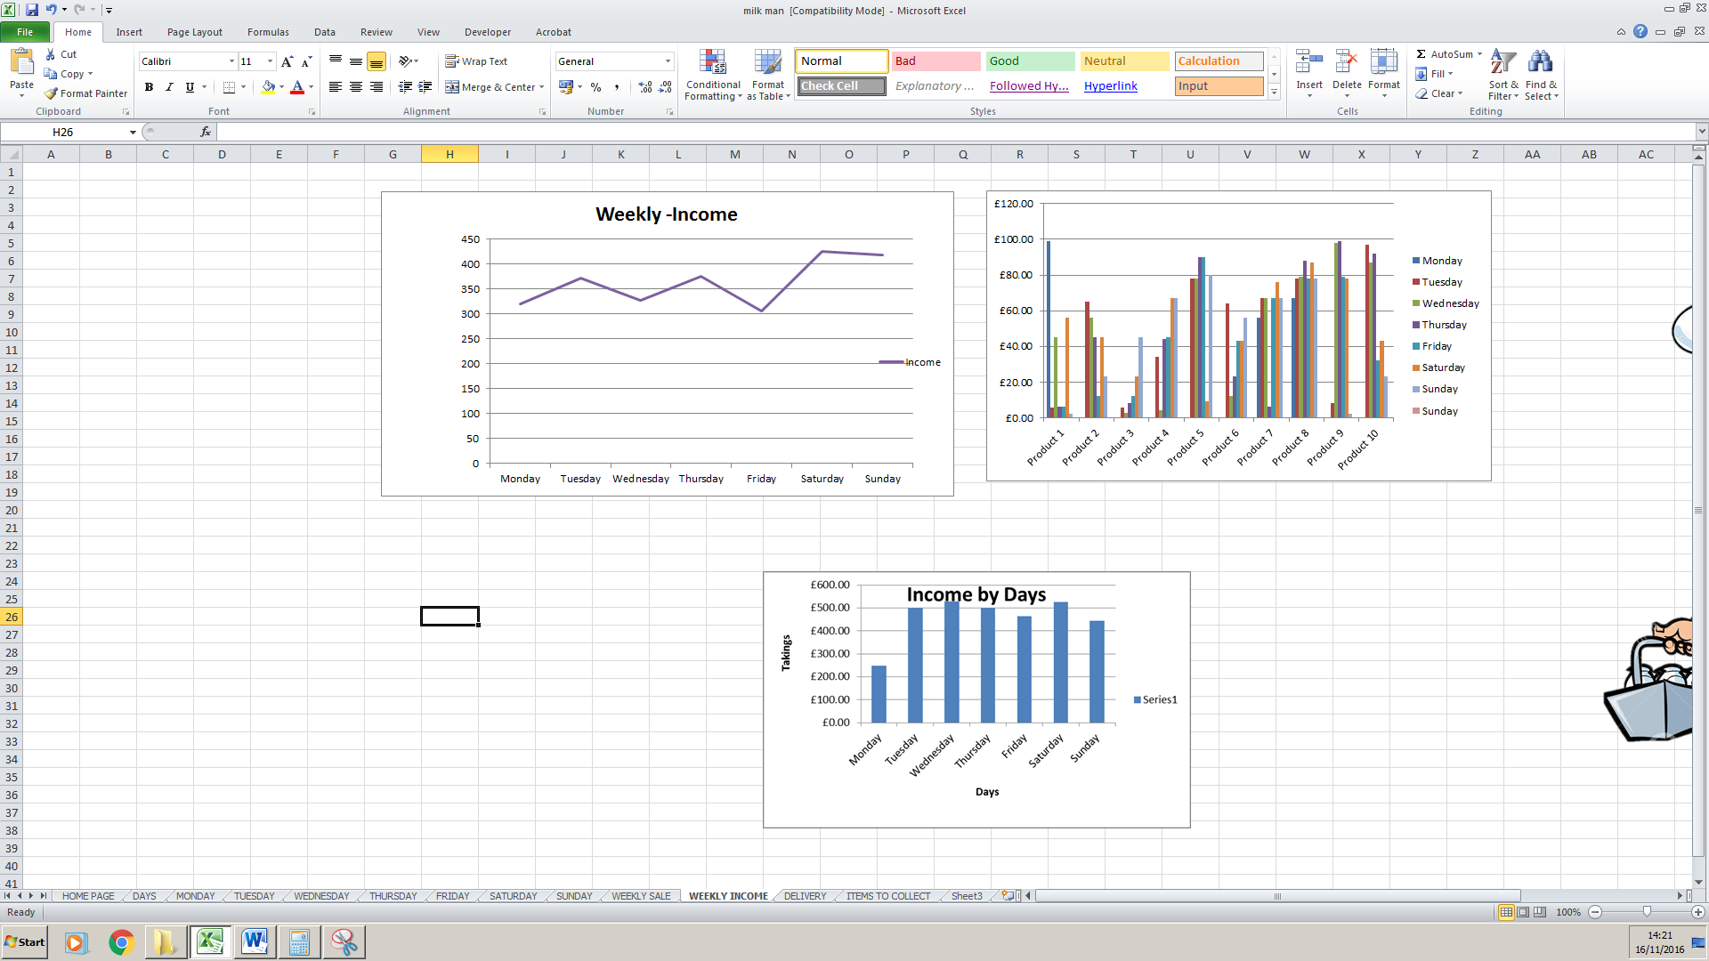
This is the spreadsheet for the graphs of incomes it will change depend in the incomes
Before
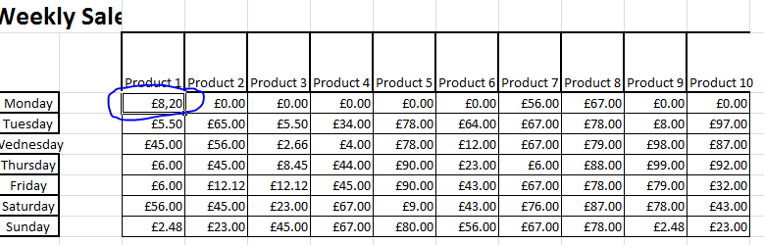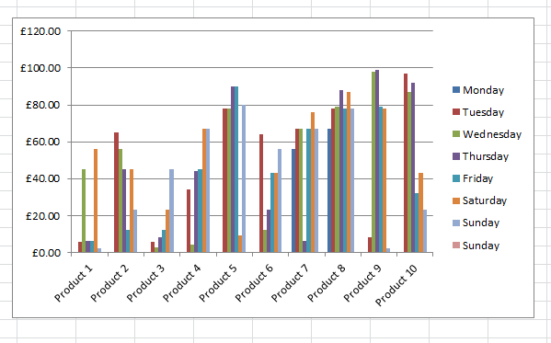
After
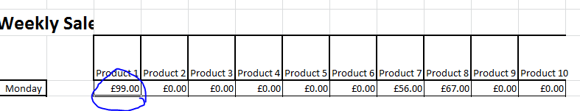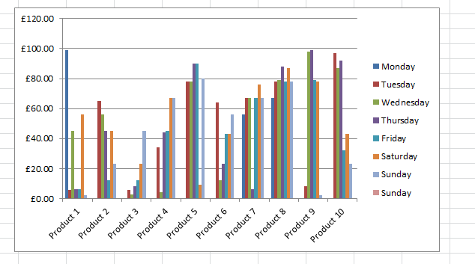
In this screenshot you can see that if you increase the product in the table that he also increase in the graph.
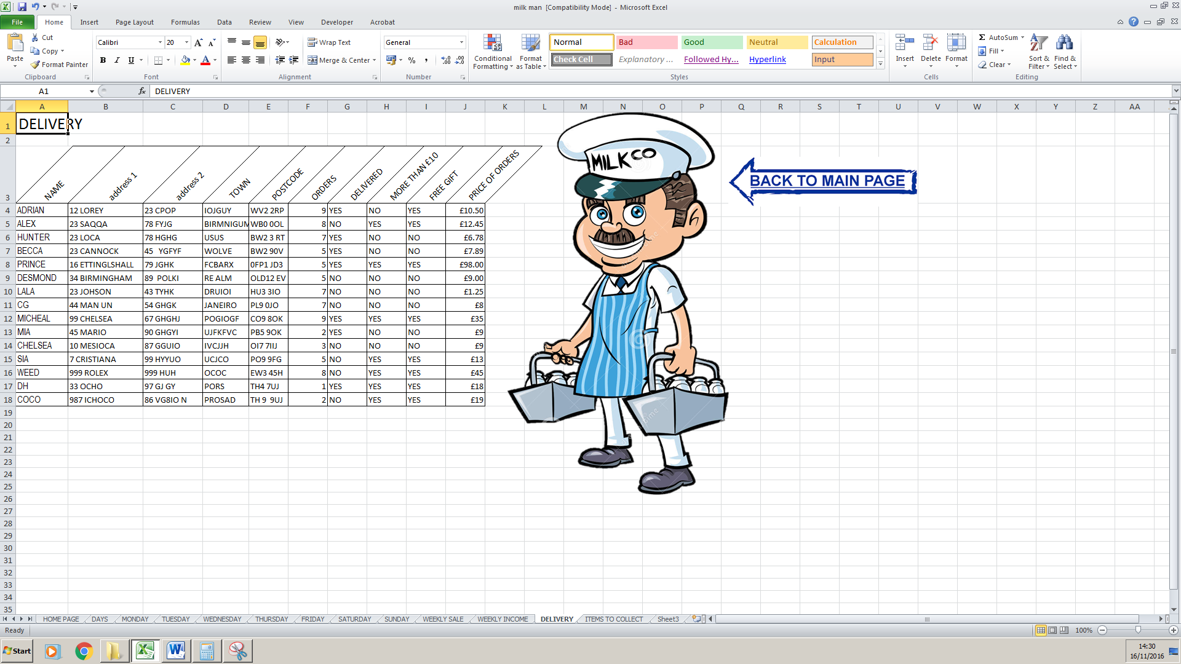in this spreadsheet the milkman can see the names of the customer,address,town,postcode ,orders delivered ,free gift and price of orders.
Before
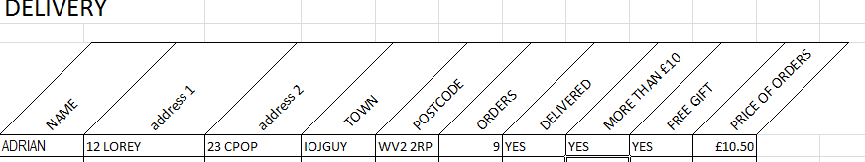
After
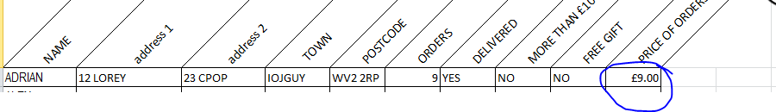
If the milkman change the price of order the more than £10 and free gift will change depend if the price of the order is more than £10

